Task: 1

What is SDLC?

The Software Development Life Cycle (SDLC) is a structured process used to guide software development from initial planning to maintenance and deployment.

Started with planning, where we have to define the project and collecting the data what we need to design the project as per the requirements then we have to arrange the things to give correct guide to give the coding or development and then of there are any things got wrong we will go for testing and finally we deploy and we have to maintain with stake holders’ requirements.

Task 2:

Why is SDLC ?

The SDLC is ensure the projects completed efficiently, and within budget we can give high quality products to user. And it is manual for the structured process.

Task 3:

What are the stages of SDLC ? write 2 lines about each.

There are 6 types of stages in SDLC

**Planning:** Here we setting the project and defining goals as per client or stake holder requirements. In simple words it is an outline of the structure.

**Design**: Here we will create the overall structure as per the requirements, where it includes designing the structure and blueprint

**Coding:** Here we write code based on the design structure and specifications and build the software.

**Testing**: Here the developed software functions correctly and meet specified requirements. Testing various aspects of the software.

**Deployment**: Here the software is ready to end user after testing is passed all the bugs.

**Maintain**: Here we update and give the support to the user.

Task 4:

SDLC Models:

List them , description - 4 lines min and with a image

**Water fall model:** This model is a linear and sequential approach to the software development. Where each one is depending on the deliverables of the previous one and corresponds to a specialization. It is easy to manage due to its rigid structure. However, it’s not flexible for handling changes once it is completed.

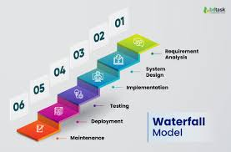

**Applications**:

Waterfall model application is best for small, simple projects with well defined requirements. This is suitable where documentations is crucial. These are used in industries like constructions and manufacturing. Nasa, banking, hospital

**Advantages and Disadvantages**:

Water fall model is good at simple and easy to understand and use and manage where poor model for long or ongoing projects and inflexible and difficult to go back to the previous stage

**V- model :** This is also known as validation and verification model. It extends the waterfall by associating each development and testing stage with a testing phase. Development and testing happens simultaneously in a V shape. This model is ideal for projects where requirements are very clearly defined.

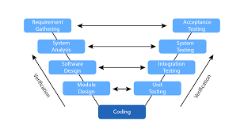

**Applications**:

V model application used in safty- critical system like medical devices where preferred in embedded systems where high reliability is needed.

**Advantages and Disadvantages**:

V model is emphasizing testing at every stage and easy to manage and ensures quality whereas very rigid and less flexible and high cost and time due to extensive testing.

**Incremental Model:** The software is built and delivered in small fuctionals. Each increment adds a functional component until the full system is complete. This model is more flexible than waterfall and reduces initial delivery time.

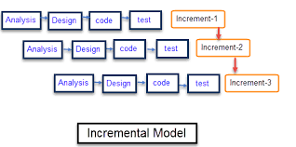

**Applications**:

Incremental model is used in web applications and online systems where features are added over time for the projects where early partial product is beneficial. Helpful in startups or products evolving with user feedback.

**Advantages and Disadvantages**:

Incremental model is used in web applications and online systems where features are added over time for the projects where early partial product is beneficial. Helpful in startups or products evolving with user feedback.

**Spiral model:** This combines iterative development with the systematic risk analysis. It is used for large, complex and high risk projects. It helps in managing risks and redefining the product at every loop.

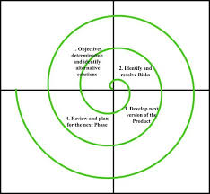

**Applications**:

Spiral model is used in large high-risk projects. Used in frequent risk evaluation and user feedback are needed. Suitable for R and d software applications.

**Advantages and Disadvantages**:

Spiral model is very good in risk management and suited for large, high- risk projects but it can be time consuming and requires in risk assessment and it is not complex and costly.

**Agile model:** this promotes adaptive planning and evolutionary development. Works is divided into small cycles called sprints. It encourages customers feedback, flexibility, and continuous improvement. It is based on iterative development where requirements and solution evolve through collaborations.

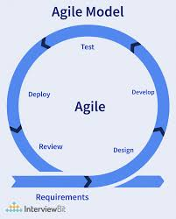

**Applications**:

Agile model applications popular in startups, web development. This is for projects requiring frequent updates and customer collaboration. e- mobile app , social networks and e commerce platforms.

**Advantages and Disadvantages**:

Agile model is high flexible and adaptable to change and continuous customer involvement and gives working software quickly and frequently whereas requires experience team and customer availability.

**Big bang**: this is minimal planning required and suitable for small projects or experimentation but it is high risk and difficult to manage and it is not good for large or complex projects.

Task 5:

Applications of SDLC

Task 6:

Advantages and Disadvantages of SDLC Models

These 2 task answers are given in the task 4.

Task 7:

What is scrum?

It is an agile framework for managing and completing the projects, where the team can work together, most commonly used development, where work is broken into fixed length iteration called sprints.

Task 8

What is Sprint?

It is a fixed length , time – boxed iteration , which takes typically 1 to 4 weeks, During which the scrum team works to deliver the project. it adapt both product and their process in short and continuous improvement.

Task 9:

Do’s:

Stick to the agreed upon goal for the sprint.

Break down the points into tasks and spotting blockers.

Hold effective daily scrums.

Don’ts:

Avoiding the backlogs when we start the sprint.

If urgent work arises discuss scope trade with product owner before.

Cross functional teamwork.

Show the increments early and often in the sprint review.

Task 10:

What are stories and Backlogs in Scrum World?

Stories refers to user stories which are small functional pieces of work from the users perspective. Like if the user need a simple descriptions of the feature or requirement, these are usually told from the end user

Backlogs are to organized lists of those stories and other work.

Task 11:

Scrum Artifacts

Product Backlog

* Sprint Backlog
* Burn-Down Chart
* Increment

Can you brief the above Artifacts

Product backlog : a prioritized list of everything that might be needed in the product and this is maintained by the product owner.

It includes the user stories, bug fixes, technical task and more. It is based on feedback and changing the requirements.

Sprint backlog:

A subset of the product backlog selected for a specific sprint. Supports visibility and transparency during the sprint. Where we owned and updated daily by the team.

Increment:

The sum of all completed work at the end of a sprint and must be done according to the teams definition of done.

Burndown chart:

It is a visual tool in scrum that shows how much work remains in a sprint. It helps teams identify riskes early , such as falling behind schedule, and continuous improvement.

Task 12:

What are ports and protocols?

Ports are virtual channels on a device used to identify specific services or apps should handle incoming or outgoing date.

Protocols are rules for how data is transmitted over a network, which defines how computers communicate over a network.

Task 13:

What are different network types?

LAN – local area network

covers a small area like home , office, school.

High speed and low cost.

MAN – metropolitan area network

Covers a city or large campus.

Larger that LAN, smaller than WAN

WAN – wide area network

Covers large geographic area like countries continents.

Internet is the biggest example.

Slower and more complex than LANs.

PAN – personal area network

Very small area, around a single person.

Includes devices like mobiles, laptops etc.

CAN - campus area network

Covers multiple LANS in a campus.

Intermediate size and speed.

SAN – storage area network

A high speed network that provides access to storage divices.

Used in date centers for handling large volumes of date efficiently.

Task 14:

What are the types of servers ?

Web server: websites and deliveries web pages to browsers.

File server: stores and manages files, allows users to access and share them over a network.

Database server: stores and manages and process data using databases.

Mail server: sends, receives and stores emails.

Application server: Runs business apps and services between users and database.

DNS sever: Resolves domain names to IP address

Virtual server: A software- based server that shares hardware with others using virtualization.

Task 15:

What do you know about DNS? Domain Name System

DNS is like the phone book of the internet where it translates domain names like [www. com](http://www.com) into IP address so computers can find each other. Because the computers communicate using IP address, but human remember names better so dns helps and act like a bridge the gap by resolving domain names to IP address.

Task 16:

What are the types of topology?

**Bus topology:** All devices share a single communication line. It is easy to install and cheap. If backbone fails whole network goes down.

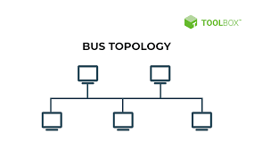

**Star topology:** All devices are connected to a central device which is known as a switch or hub. It is easy to manage. If central hub fails, network fails.

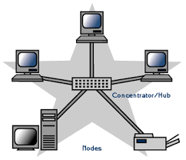

**Ring topology**: Devices are connected in a closed loop. Date travels in one direction or both. It is good for performance under light load. One break can disrupt the whole network.

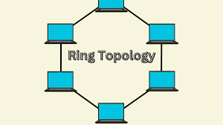

**Mesh topology:** Every device is connected to every other device. High reliability and it is expensive and complex to set up.

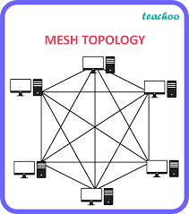

**Tree topology:** A combination of star and bus where hierarchical structure with root not branches. It is highly recommended for large networks, it is depends on backbone same as bus if it fails the network segments fail.

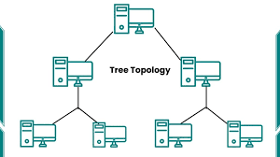

Each topology suits different needs based on cost, reliability scalability and performance.

Task 17:

What is OSI Model ?

Describe the 7 layers with description.

The OSI model open systems interconnection is a framework that standardizes how data travels from one device to another over a network.

**Physical layer:** Transmits raw bits over physical media like cables, etc. Deals with hardware.

**Date link layer:** Handles error detection, MAC address and organizes bit into frames.

**Network layer:** The path data using IP address and handles routing.

**Transport layer:** Breaks data into segments, ensures reliable delivery and fast delivery without guarantee.

**Session layer:** Controls dialogues between computers and Manages sessions like start, maintain, end communication btw systems.

**Presentation layer:** translates data formatted. Ensures different systems can understand each other.

**Application layer:** Interface for end users like browsers, email, apps, protocols.